**STORE MANAGEMENT SYSTEM**

The store management system is designed to effectively manage and track various aspects of a store house operation.

**How store management system works**

A store management system efficiently handles the storage, tracking, and retrieval of items, ensuring smooth operations and customer satisfaction. Here’s how it works:

**Customer Interaction**: Customers bring items to the warehouse for storage. They are registered in the system, and their items are recorded with details such as item ID, section ID, and location ID.

**Storage Assignment:** Items are assigned to specific compartments within the appropriate section based on their category.

**Payment Processing**: Customers make payments for the storage service, which are recorded in the system under their customer ID.

**Employee Management:** Employees are assigned to manage specific sections and compartments, ensuring items are stored correctly and regular inspections are conducted.

**Inspections**: Periodic inspections are carried out to check the condition of stored items. Inspection results are recorded, and any issues are promptly addressed.

**. Actors:**

**Customer**

**Employee**

**Store manager**

**Inspector**

**The following are the actors interacting with the system**;

**Custome**r. Purchases products, makes payments

**Employee**. inspects the items, records the inspection results.

**Store Manager**. Manages sections, items, compartments, and employees

**Inspector.**

Perform inspections, record inspection data.

performs inspections on the store's compartments and items, ensuring compliance with safety and quality standards.

**Benefits of Using Case Diagrams in Store Management**

**Clear visualization**: Case diagrams provide a visual representation of the system's functionality, making it easier to understand.

**Requirement gathering**: They help in identifying the specific needs and goals of the users.

**System design**: Case diagrams can be used as a basis for designing the system's architecture and functionality.

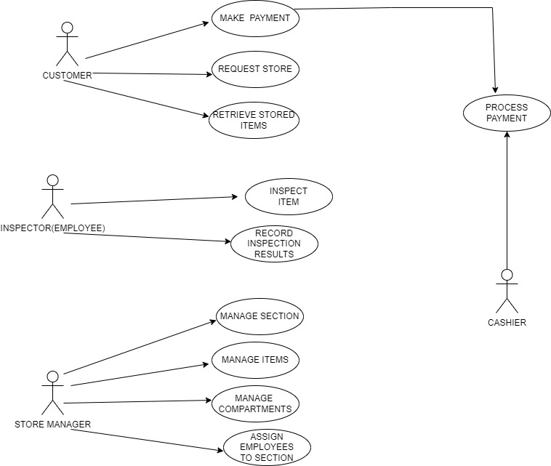

**Sequence Diagrams**

Purpose: Sequence diagrams illustrate the interactions between objects or components in the system over time. They show the order of messages exchanged to perform a specific function.

**Components:**

**Objects/Participants:** Represent the entities involved in the interaction. Examples include Customer, System, Employee, and Payment Processor.

**Lifelines**: Vertical dashed lines that represent the existence of an object over time.

**Messages**: Horizontal arrows that show communication between objects. They can be synchronous (waiting for a response) or asynchronous (not waiting for a response).

**Activation Bars**: Thin rectangles on lifelines that indicate when an object is active or performing an action.

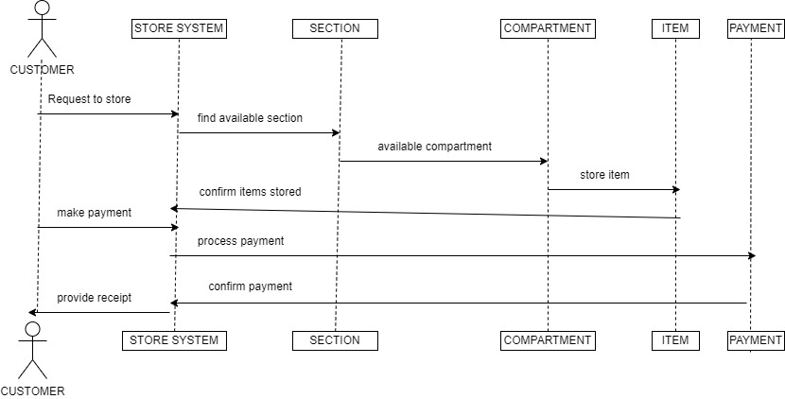

**CLASS DIAGRAMS**

**Description of Each Entity:**

**Section:** Contains attributes and methods to manage the storage sections within the warehouse. It has a one-to-many relationship with Compartment and Employees.

**Compartment**: Each compartment holds specific items. It's linked to the section it belongs to and can store multiple Items.

Item: A specific product that is stored in a compartment within a section. Items can also be inspected.

**Customer:** Stores items in the warehouse and makes payments for the services. A customer can store multiple items and make multiple payments.

**Payment**: Manages financial transactions related to a customer’s use of the storage services.

**Employees:** Works within a specific section and performs item inspections.

**Inspection:** Tracks the inspection details for an item, including the results and the employee who performed the inspection.

**How the Class Diagram Works?**

The Section manages multiple compartments, and each Compartment stores multiple items.

Customers can store items and make payments for those services.

Employees are responsible for managing sections and performing inspections.

Inspections record details about the condition of items and link to both the Item and Employees.

**This class diagram provides a structured representation of how the entities in your store management system interact and operate**

